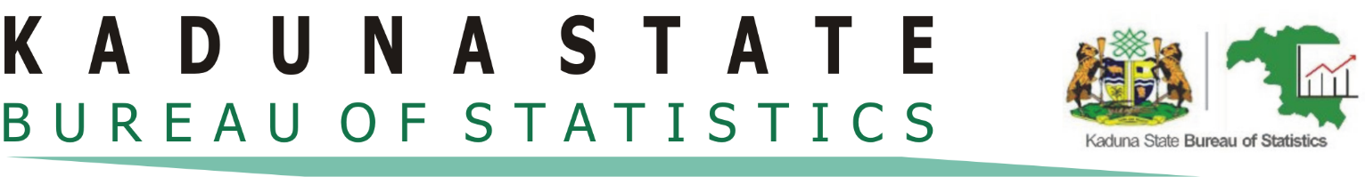

CPI REPORT JULY, 2022
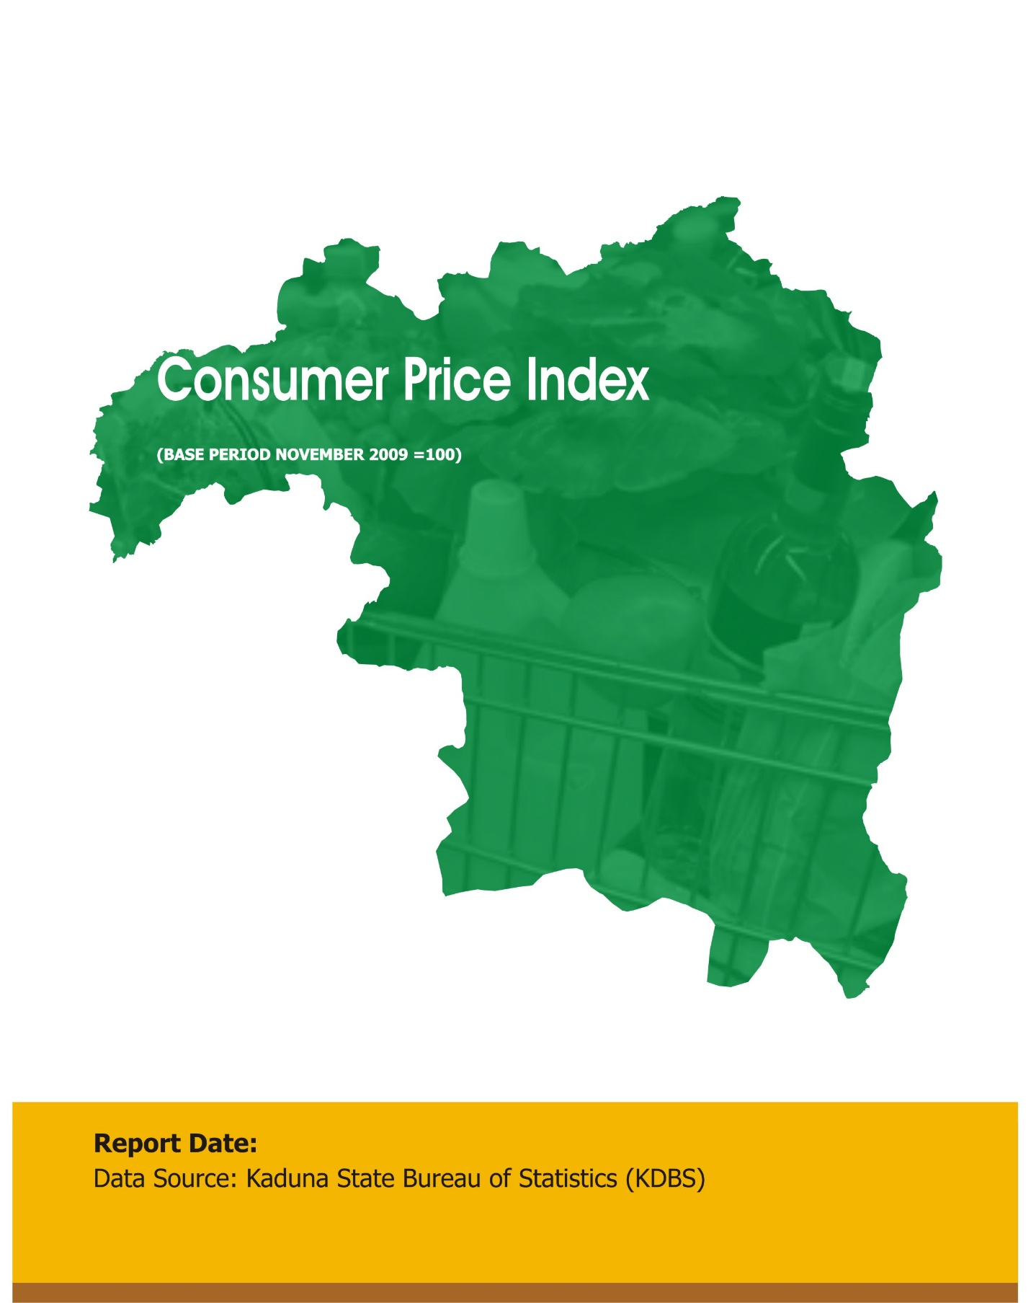

August Report, 2022
July Report, 2022

Contents
Executive Summary 3
Methodology 4
Acknowledgements 4
Consumer Price Index July 2022 Report 5
Kaduna State Year On Year Inflation Trend 12 Month Series 6
Kaduna State Month On Month Inflation Rate Trend 12 Months Series …………………….…..6
Kaduna State Month On Month CPI Trend 12 Months Series …………………………………….…7
Kaduna State and Nigeria Inflation Trend 12 Month Series……………………….……………...7
Jun 2022 and Jul 2022 North West States Inflation Trend……………………..………………….8
Table 1: Kaduna State Year on Year Inflation Rate 12 Months Series…….……………………9
Table 2: Top Five Absolute Contribution to Kad State July 2022 M On M Inflation Rate….9
Table 3: Kaduna State Month on Month Inflation Rate 12 Months Series……………….…10
Table 4: Kaduna State Month on Month CPI 12 Months Series…………………………….......10
Table 5: Kaduna State and Nigeria Inflation Rate 12 Months Series……………………………11
Table 6: North West States Inflation Rate from National Bureau of Statistics (NBS)…….11

Executive Summary
The Kaduna State Consumer Price Index (CPI) report, July 2022 shows the state’s Year on Year and Month on Month Inflation Rate.
The Consumer Price Index (CPI) measures the average change in the price level of market basket of consumer goods and services purchased by households and a very important key indicator of inflationary change which measures state of an economy.
The Kaduna State CPI Report is targeted at providing Kaduna State with Monthly average changes of selected Goods and Services consumed by people for day-to-day living as well as showing the Year-on-Year Inflation rate of the State.
The CPI Year-On-Year Inflation Rate for Kaduna State stands at 17.12% in July, 2022. This was 0.36% higher than the rate of 16.76% recorded in Jun, 2022.

METHODOLOGY
The Consumer Price Index (CPI) measures the average change over time in prices of Goods and Services consumed by people for day-to-day living. The construction of the CPI combines economic theory, sampling and other statistical techniques using data from other surveys to produce a weighted measure of average price changes in Kaduna State Economy. The weighting occurs to capture the importance of the selected commodities in the entire index. The production of the CPI requires skills of economists, statisticians, computer scientists, data collectors and others.
Key in the construction of Price Index is the selection of Market Basket of Goods and Services. The market items currently comprise of 221 Goods and Services regularly priced.
The first stage in the calculation of the CPI is the collection of prices on each item (221 Goods and Services) from Markets and Outlets in each sector (Rural and Urban). Prices are then averaged for each item per sector across the state. Then the average price is used to calculate the basic index for each commodity: The current year price of each commodity is compared with a base year's (2009) price to obtain a relative price.
The Laspeyres formula was used to compute an aggregated index for each class (which has a multitude of commodities that have similar consumption purposes). The sum of the product of weights (obtained from the expenditure survey) and relative prices for each item is divided by the sum of the weight of the items in that class, and the result multiplied by 100 gives the required index number. This index number is still classified according to the urban or rural classification sector for each of the 23 LGAs of the state.

CONSUMER PRICE INDEX (CPI) REPORT FOR JULY, 2022.
The consumer price index, (CPI) which measures inflation rate increased to 17.12% (year-on -year) in July, 2022. This is 0.36% higher than the rate of 16.76% recorded in June, 2022. This shows that price of some goods and services increased in July, 2022 when compared to the inflation rate recorded in June, 2022.
The CPI Month – on – Month basis in Kaduna State shows that the State Index stands at 284.02% in July, 2022.The urban Index recorded 281.11% while rural index recorded 289.35% in July, 2022.
The State CPI Month – on - Month Inflation rate was 20.81% in July, 2022, up by 1.88% from 18.93% recorded in June, 2022.
The Urban Inflation Rate was 22.90% in July, 2022, increased by 4.58% from 18.32% recorded in June, 2022.
The Rural Inflation Rate was 22.52% in July, 2022 increased by 1.20% from 21.32% recorded in June, 2022.
The percentage change in the average composite CPI for the twelve-month period ending July, 2022 over the average of the CPI for the previous twelve-month period was 16.90%, showing 0.05% decrease from 16.95% recorded in June, 2022.
The corresponding twelve-month year-on-year average percentage change for the urban index is 12.83% in July, 2022. This is higher than 12.48% reported in June 2022, while the corresponding rural inflation rate in July, 2022 is 18.42% compared to 18.31% recorded in June, 2022.

Figure 1
The Top Five Absolute contribution that influenced the increase of the Month-on-Month July, 2022 CPI Inflation Rate included: Bread & Cereals 6.32%, Fat and Oil 5.32%, Food Product NEC 5.30%, Vegetables 4.65% and Gas 4.25%.
The highest contribution to the increase of July, 2022 Month-on-Month Inflation rate was recorded in Bread & Cereals 6.32%.

Figure 2

Figure 3

Figure 4

Figure 5
The CPI Year-On-Year Inflation Rate for Kaduna State increased constantly within the period of 2022 from 15.31% in January, 15.39% in February, 15.95% in March 16.01% in April, 16.22% in May, 16.76% in June and 17.12% in July 2022 with an average of 16.11% Inflation Rate.
This implies that prices of some commodities inclined constantly from Jan to Jul, 2022 but at a slower rate compared to the same periods of 2021.
The chart below depicts the Kaduna State January to July, 2022 Year on Year Inflation Trend.

Figure 6

Figure 6

Appendix

TABLE 1: KADUNA STATE JULY, 2022 YEAR ON YEAR INFLATION RATE 12 MONTHS SERIES
MONTHS | INFLATION RATE
2021 Jul | 18.23
2021 Aug | 17.29
2021 Sept | 17.79
2021 Oct | 17.97
2021 Nov | 17.94
2021 Dec | 17.74
2022 Jan | 15.31
2022 Feb | 15.39
2022 Mar | 15.95
2022 Apr | 16.01
2022 May | 16.22
2022 Jun | 16.76
2022 Jul | 17.12
Average | 16.90

TABLE 2: TOP FIVE ABSOLUTE CONTRIBUTIONS TO KADUNA STATE JULY, 2022 MONTH-ON-MONTH INFLATION RATE
Top Five Absolute Contributions to Month-on-Month Inflation Rate
1 | Bread and Cereals | 6.32%
2 | Fat and Oil | 5.32%
3 | Food Product NEC | 5.30%
4 | Vegetables | 4.65%
5 | Gas | 4.25%

TABLE 3: KADUNA STATE MONTH ON MONTH INFLATION RATE 12 MONTHS SERIES
MONTHS | INFLATION RATE
2021 Jul | 33.83
2021 Aug | 33.39
2021 Sept | 16.27
2021 Oct | 18.93
2021 Nov | 16.52
2021 Dec | 16.77
2022 Jan | 15.75
2022 Feb | 16.34
2022 Mar | 17.83
2022 Apr | 18.47
2022 May | 18.87
2022 Jun | 18.93
2022 Jul | 20.18
Average | 20.16

TABLE 4: KADUNA STATE MONTH ON MONTH CPI 12 MONTHS SERIES
MONTHS | CPI
2021 Jul | 242.50
2021 Aug | 241.72
2021 Sept | 243.12
2021 Oct | 238.50
2021 Nov | 243.65
2021 Dec | 244.16
2022 Jan | 242.02
2022 Feb | 243.27
2022 Mar | 246.39
2022 Apr | 247.71
2022 May | 248.55
2022 Jun | 248.69
2022 Jul | 284.02

TABLE 5: KADUNA STATE AND NIGERIA INFLATION RATE 12 MONTH SERIES
MONTHS | Kaduna State Inflation Rate | Nigerian Inflation rate
2021 Jul | 18.23 | 17.38
2021 Aug | 17.29 | 17.01
2021 Sept | 17.79 | 16.63
2021 Oct | 17.97 | 15.99
2021 Nov | 17.94 | 15.40
2021 Dec | 17.74 | 15.63
2022 Jan | 15.31 | 15.60
2022 Feb | 15.39 | 15.70
2022 Mar | 15.95 | 15.92
2022 Apr | 16.01 | 16.82
2022 May | 16.22 | 17.71
2022 Jun | 16.76 | 18.60
2022 Jul | 17.12 | 19.64

TABLE 5: KADUNA STATE JAN-JULY 2022 INFLATION RATE
MONTHS | Kaduna State Inflation Rate
Jan | 15.31
Feb | 15.39
Mar | 15.95
Apr | 16.01
May | 16.22
Jun | 16.76
Jul | 17.12

NORTH-WEST STATES JUNE AND JULY, 2022 INFLATION RATE
STATE | JUN 2022 INFLATION RATE | JUL 2022 INFLATION RATE
Jigawa | 16.37 | 16.62
Kano | 17.91 | 18.74
Katsina | 17.57 | 19.02
Kebbi | 19.94 | 19.88
Sokoto | 16.31 | 19.02
Zamfara | 18.94 | 19.29

