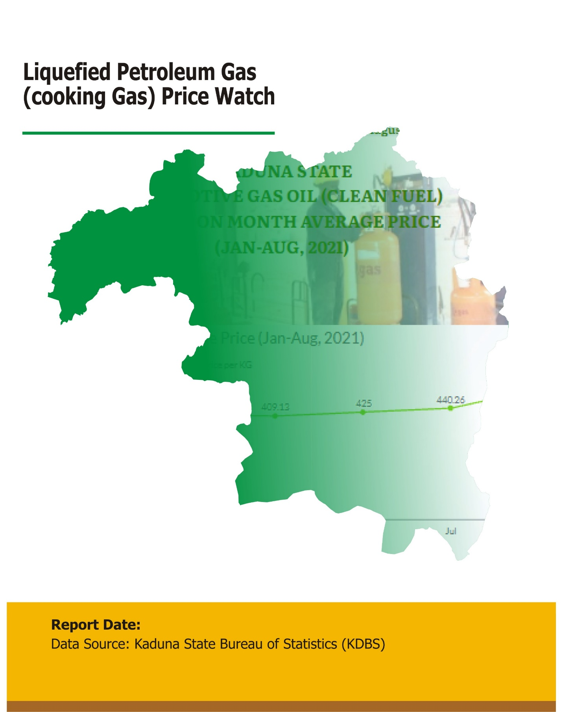

August, 2022

July Report, 2022

Contents

Executive Summary…………………………………………………………………………….………………..2

Methodology………………………………………………………………………………….…………..………..2

Acknowledgements.……………………………………………………………………….……………..……...2

July, 2022 Liquefied Petroleum Gas Average Price Watch (Per Kg) Across 23 Lgas Of Kaduna State…………………………………………………………………………………….……………..…..3

July, 2022 Liquefied Petroleum Gas Average Price Trend (Per Kg) Across Lgas…………………………………………………………………………………………………………………….4

Kaduna State July, 2022 Year On Year Liquefied Petroleum Gas Average Price Change (Per Kg)………………………………..……………………………………………………………………………..5

Jan-July, 2022 Kaduna State Month on Month Change of Liquefied Petroleum Gas Price Watch (Per Kg) ……………………………………….…………………………….………………….……......5

Kaduna State Jan-July, 2022 Month on Month Change Liquefied Petroleum Gas Price Watch (Per Kg) ………………….…………………………………………………………………………………6

Jan-July, 2022 Kaduna State Month on Month Average Price of Liquefied Petroleum Gas Price Watch (Per Kg) ………………………………….………………………………………………………….7

Kaduna State Month on Month Average Price of Liquefied Petroleum Gas Price Watch Trend…………………………………………………………………………………………………………………..7

**Executive Summary**

The Kaduna State Liquefied Petroleum Gas Average Price Watch is targeted at providing a Monthly average change of Liquefied Petroleum Gas Average Price (Per KG)consumed by people for day-to-day living as well as showing the Year-on-Year average changes in the State.

The average price paid by consumers for Liquefied Petroleum Gas Average Price (Per KG) Increased by 0.85% Month-on-Month, from N798.23 in June, 2022 to N805.01 in July, 2022 and Increased by 74.90% year-on-year from N460.27 in July, 2021 to N805.01 in July, 2022.

The Local Government Areas with the highest Monthly average price of Liquefied Petroleum Gas (Per KG) in July, 2022 were Kauru (N900.00), Lere (N880.00) and Zangon Kataf LGA (N864.00).

The Local Government Areas with the lowest Monthly average price of Liquefied Petroleum Gas (Per KG) in July, 2022 were Igabi, Kaduna South and Kaduna North LGAs with (N780.00) each.

**Methodology**

Kaduna State Bureau of Statistics Field Officers were spread across the 23 LGAs to collect the Price Statistics Data weekly, using an online electronic template. The data is use to facilitate the analysis of average changes in prices of some selected commodities. Fuel Prices are collected across all the 23 local government areas of the States.

The average of all these prices is then reported Per KGfor each LGA of the State.

KDBS team regularly conducts online verification of prices sent by the field officers weekly.

**Acknowledgements**

We acknowledge KDBS Publication team, GIS Division in the design, concept and production of this publication.

|  |  |
| --- | --- |
| **JULY, 2022 KADUNA STATE LIQUEFIED PETROLEUM GAS AVERAGE PRICE WATCH (PER KG)** |  |
| **LGAs** | **Jul-22** |
| Birnin Gwari | 800.00 |
| Chikun | 800.00 |
| Giwa | 800.00 |
| Igabi | 780.00 |
| Ikara | 800.00 |
| Jaba | 800.00 |
| Jemaa | 800.00 |
| Kachia | 800.00 |
| Kaduna North | 780.00 |
| Kaduna South | 780.00 |
| Kagarko | 784.00 |
| Kajuru | 800.00 |
| Kaura | 792.00 |
| Kauru | 900.00 |
| Kubau | 784.00 |
| Kudan | 819.20 |
| Lere | 880.00 |
| Makarfi | 816.00 |
| Sabon Gari | 784.00 |
| Sanga | 784.00 |
| Soba | 784.00 |
| Zangon Kataf | 864.00 |
| Zaria | 784.00 |
| **State Average Price** | **805.01** |





|  |  |  |  |  |  |  |  |
| --- | --- | --- | --- | --- | --- | --- | --- |
| **KADUNA STATE JAN-JUL 2022, MONTH ON MONTH AVERAGE PRICE OF LIQUEFIED PETROLEUM GAS PRICE WATCH (PER KG)** | **Column1** | **Column2** | **Column3** | **Column4** | **Column5** | **Column6** | **Column 7** |
|  | Jan-22 | Feb-22 | Mar-22 | Apr-22 | May-22 | Jun-22 | Jul-22 |
| Kaduna State Gas Oil Average Price | 679.91 | 682.70 | 717.65 | 733.83 | 787.74 | 798.23 | 805.01 |